**Correlating Patient Feedback to Avoidable**

**Readmissions and Patient Experience Outcomes**

Capstone 1 - Final Project Report

Florida Polytechnic University

Fall 2021

submitted by:

The Three Musketeers

Hailey Skoglund – Business Analytics

Gus Lipkin - Business Analytics

Maverick Hope - Business Analytics

submitted to:

Dr. Jim Mennie

[12/08/2021]

Table of Contents

Executive Summary 3

Introduction 3

2.1 Customer Needs, Objectives and Team Interpretation 3

2.3 Design Objectives 3

2.4 Team Interpretation 4

2.5 Functional and Non-functional Requirements 4

2.6 Limitations 4

Concept Generation and Analysis of Alternatives 4

3.1 Literature Search 4

3.2 Concept Generation 5

3.3 Analysis of Alternatives 5

3.4 Flow Chart of Design Process 6

3.5 Work Breakdown Structure 6

3.6 Gantt Chart 7

3.7 Functional Decomposition 7

3.8 Data Flow Diagram 8

4 Data Analysis 9

4.1 Exploratory Data Analysis (EDA) 9

4.2 Research Question Two 10

Related Design 11

Conclusions and Future Work 11

6.1 Conclusions and Project Summary 12

6.2 Plan for End-Product Demonstration 12

6.3 Next Steps 12

References 13

Appendix 1 - Customer Needs, Requirements and Objectives 14

Appendix 2 – Data Visualizations in R 15

Appendix 3 – Project Charter 17

# Executive Summary

The purpose of this report is to examine and analyze the steps that have been taken thus far in our Data Analytics Capstone project. In this way, this report aims to address our project overview, research design, and future plans for the next steps of our project. By the completion of our project, our goal is to discuss the findings from our data analysis to identify areas of improvement in avoidable readmissions and HCAHPS scores at Tallahassee Memorial Healthcare. This report will discuss the actions we have taken up to the end of the term and those actions that we plan to take as our project progresses. We will also examine the various project management tools that were implemented into our decision-making processes to construct our Project Charter, Work Breakdown Structure (WBS), and Gantt Chart and how well our team has been able to execute those plans. Our team is confident that this detailed update of our Data Analytics Capstone project for Tallahassee Memorial Healthcare will summarize our project, report our progress thus far, outline our research and analysis framework, and discuss our plans for the next steps of this project.

# Introduction

As a strategy to better understand and ultimately improve avoidable readmissions and HCAHPS scores at Tallahassee Memorial Healthcare (TMH), the Organizational Improvement (OI) team at TMH requested that our team assist in investigating any possible correlations between follow-up phone call survey responses and two outcomes: readmissions and patient surveys. Our goal is to explore the data to identify what patient response characteristics are more likely to result in patients being readmitted into the hospital or poor survey responses. For this project, our primary focus is on reducing avoidable readmissions and improving HCAHPS scores at Tallahassee Memorial Healthcare.

## 2.1 Customer Needs, Objectives and Team Interpretation

After speaking with Tallahassee Memorial Healthcare (TMH), there were three project objectives that were discussed to fulfill the customer’s needs. First, TMH is interested in us analyzing the data to see whether there is any correlation between phone call responses and outcomes of readmissions or patient surveys scores (HCAHPS), survey scores. Next, TMH would like our capstone team to use the provided data to identify the patient response characteristics that have the strongest relationship to these two outcomes. Lastly, our team was tasked with analyzing if there are any correlations between patient response characteristics.

## 2.3 Design Objectives

Our design objectives are to create a report for TMH that answers the three project objectives stated in the previous section. This will include detailed answers and visuals to the project objectives as well as interesting findings that would be beneficial for TMH. If we have extra time after all of this is completed, we hope to either receive further questions from TMH about their data that we can answer for them or additionally offer potential ways to make their healthcare systems better so that HCAHPS scores will go up and readmissions will go down. This may include suggestions such as having doctors’ notes and prescription instruction being typed out and printed to give to the patient before they leave, create a patient portal to access their medical information, appointments, test results and other important information, and including more telehealth options such as video appointment for when tests are not needed yet.

## 2.4 Team Interpretation

Our team’s interpretation of these objectives was broken down into our three research questions. First, we decided to tackle research question two which sought to discover if there are any correlations between the patient response characteristics and the two outcomes of readmission and connect call scores.

## 2.5 Functional and Non-functional Requirements

Our functional requirements are our analysis of the research questions and our report for TMH. Our non-functional requirements are that the report is easy to understand and contains an accurate analysis including data visualizations that will be useful for TMH to make decisions with. Because our project is data analysis focused, our requirements are not as strict as they might be if we had a physical product as the goal of our project.

## 2.6 Limitations

The most major limitations for this project are in how the data is collected and then of that data, what we are given access to. The data for Encounters and Readmissions are automatically generated with factual data, which is good for us. However, Connect Calls are made within twenty-four hours after discharge and rely on patient perception of their stay. Surveys happen even further out. They can be delivered anywhere between four and six weeks after discharge and can be returned at any time. After so much time out of the hospital, it is likely that a patient’s memories are not an exact memory of their stay. Before we are given the data, all personal identifiers are stripped from the data so that it is HIPAA compliant. While we may not necessarily need that data that is stripped, there could be something in there that helps us.

# Concept Generation and Analysis of Alternatives

In this section we discuss our research into what results similar projects reveal as well as our concept generation and design process. One thing that stood out when doing our literature review was that lack of quality communication was often a major reason for lower HCAHPS scores. For our concept generation we split it up throughout the project so we can adapt more easily to changes. Our goal with our work breakdown structure, Gantt chart and data flow diagram is to keep it simple and easy to understand so that we could use the document as references throughout the project.

## 3.1 Literature Search

The first article that we looked at was *Improving the US hospital reimbursement: how patient satisfaction in HCAHPS reflects lower readmission*. This article looked at data on HCAHPS, 30-days readmission rates, and related payments for heart failure and pneumonia patients at 2,711 acute care hospitals in the US. They found unsurprisingly that people who rated the hospitals poorly were more likely to be readmitted to the hospital than patients who rated a hospital highly.

*Drivers of Inpatient Hospital Experience Using the HCAHPS Survey in a Canadian Setting* looked at HCAHPS data from April 1st, 2011, to March 31st in Alberta, Canada. What they found was that people who don’t have a family practitioner and people who were not discharged home to have the strongest negative impact to HCAHPS scores, but many more variables can contribute to a negative score such as being male, having a higher education, being born in Canada, and urgent admission. The main variable that was associated with a better HCAHPS score was having a hospital stay for less than 3 days.

In *Three Nursing Interventions’ Impact on HCAHPS Scores*, the authors found that three separate nursing interventions at a 28-bed surgical unit affected HCAHPS scores. The first intervention was manager rounding, which is when the manager meets with patients daily to hear any complaints which can help address them before the patient is discharged and takes the HCAHPS. The second intervention was discharge phone calls, which helped with medication compliance and lowered rehospitalization rates. Lastly, they implemented discharge teaching which standardized the practice of giving patients a physical note of all the medications and care that the patient may need as well as give them notes such as this narcotic causes constipation and to not stop the medication if that happens. All these changes had a positive effect on the surgical units HCAHPS scores. This article shows the importance of communication for improving HCAHPS and that if the patient understands what is going on they are more likely to be satisfied with their visit.

In *The Value of Patients’ Handwritten Comments on HCAHPS Surveys* the article looks at HCAHPS ratings and comments to see how they were correlated. The article found that people who rated a hospital very highly and very poorly were more likely to leave comments on the HCAHPS. Overall, 20% of patients tend to leave comments on the HCAHPS. What the article mainly focused on was the usefulness of the comments. What they found was that patients often left more context as to why they gave the scores that they did which can help hospitals to improve when they read them instead of just looking at the data from the surveys themselves.

In *Characteristics and Predictors of HCAHPS Nonresponse After Spine Surgery* they looked at HCAHPS response data from 5517 spine surgeries to find out what leads to people not responding to the survey. What they found was that people who are black, who had a minor or major adverse event, hospital readmission, or a long hospital stay were less likely to respond to the HCAHPS survey. What this showed was that for spine surgery patients those with worse outcomes were less likely to respond to the HCAHPS survey than those with positive outcomes.

## 3.2 Concept Generation

We had a good idea for what we wanted to achieve with this project quickly since we are trying to answer some basic questions about the data. First, we start with an exploratory data analysis. For the more granular details we are creating research methodologies for each of the three main objectives. Since each question does not affect each of the others, we are doing each research methodology immediately before we begin each objective allowing us to produce results more quickly at the start. We have done the research methodology for the second objective since that is what we are starting with and will complete the others when we finish the first objective.

## 3.3 Analysis of Alternatives

Because this project is analysis based, we do not have any feasible alternatives. We will be sure to follow the Cross-Industry Standard Process for Data Mining which, while not meant specifically for our types of analysis, we will be able to make sure that our process is reproducible and that we have high quality results.

## 3.4 Flow Chart of Design Process

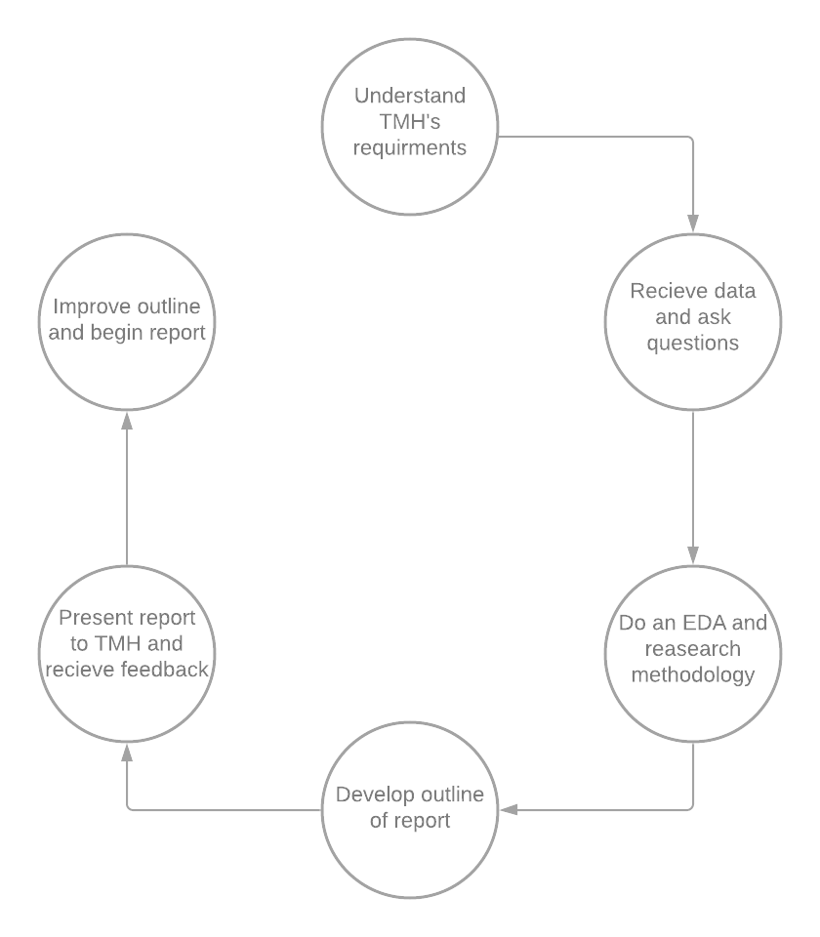

## 3.5 Work Breakdown Structure

The Work Breakdown Structure for the Tallahassee Memorial Hospital Capstone Project is relatively simple. The project is broken down into four phases: the project charter, data cleaning and exploration, the data analysis, and the report and presentation. The creation of the WBS itself is part of the project charter stage which also includes creating the project charter and the Gantt chart. All three of which are essential to defining the project, its milestones, and the project timeline. In the second section, data cleaning and exploration, we will receive data from TMH, do any more cleaning it may need, and perform an exploratory data analysis. The EDA will allow us to determine if the data we have is sufficient to answer our research questions and will give us time to become comfortable with the dataset. The data analysis comprises the most important steps. Constructing the methodology, using the methodology to conduct the analysis, and drawing the conclusions. Those three steps must be repeated for each research question. The last step is to write the final report and presentation and do the capstone showcase and report our final findings to TMH.

As of November 29, 2021, we are well into the first iteration of stage three, the data analysis. We have just completed our research methodology for research question two and will be beginning implementation this week.

## 3.6 Gantt Chart

This is our Gantt chart as of December 5, 2021. It is broken down into five distinct sections. At the top, we have a general timeline for tasks that we need Tallahassee Memorial Hospital to complete for us to be successful in our endeavors. The questions are separated into the next three sections to show that they are completely independent of each other. We can run any number of them concurrently or consecutively, or any combination thereof, including inserting additional questions where the opportunity presents itself. In addition, by separating them out, we have more flexibility in how long each one will take us. They are ordered, however, because the later questions will be made easier to answer by successfully answering the preceding questions.

Constructing our methodology for research question two took a week longer than expected and so cut into our time for extra research questions. Nevertheless, we are not at all behind and are confident that we can get back on track and hope to make up for that week and give ourselves that time for extra research questions.

## 3.7 Functional Decomposition

As illustrated below our functional decomposition diagram shows our approach to answer each of our project research questions as outlined in the deliverables provided to us by TMH. This diagram illustrated how we plan to begin with our exploratory data analysis by cleaning up and preprocessing the data, then creating data visualizations to reveal valuable insights from the data. The next step is to answer research question 1. In this step we begin by outlining the research methodology which provides a framework for how we plan to answer the research question with the given data. Next, we will run regressions to reveal any correlation between the variables being studied in the research question. Lastly, we plan to display our work in the form of aesthetic data visualizations to further convey our findings. These steps will be repeated for research question two and research question three respectively all the while remaining in communication with our sponsor, TMH, to keep them informed on our progress and findings.

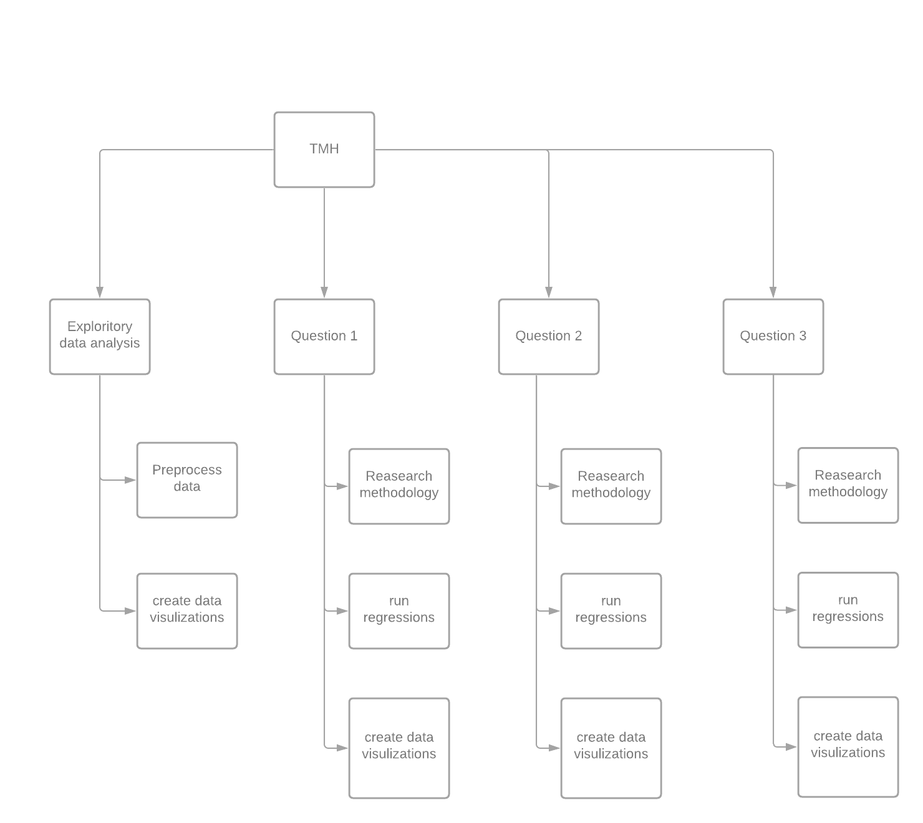

## 3.8 Data Flow Diagram

As shown in the figure below, our data flow is comprised of three major components. First is the data received from TMH. This data was then provided to our team from the Dropbox accessed by our TMH liaison from Florida Poly, Dr. Centeno. From there, we pushed this data into GitHub for further processing. Next, we imported the data into RStudio from GitHub to begin the data analysis process and create data visualizations in R. As illustrated in the diagram, the data freely flows in both directions as it is periodically saved, pushed, and pulled for version control.

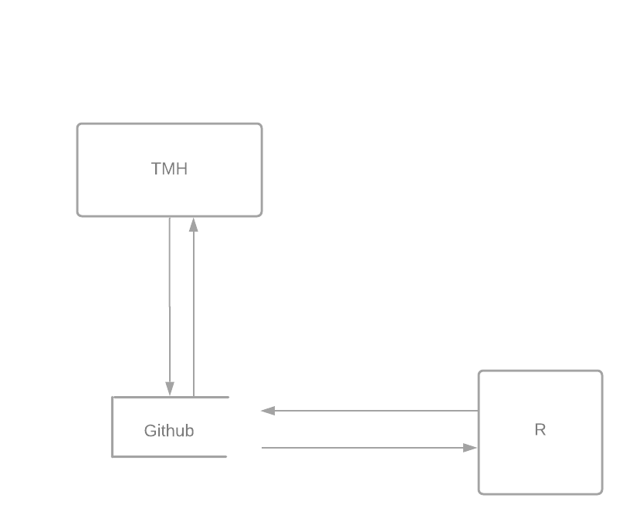

# 4 Data Analysis

For this data analysis, our goal is to provide insight on three different research questions. First, we will analyze the data to see whether there is any correlation between phone call responses and outcomes of readmissions or patient surveys scores (HCAHPS), survey scores. Next, we will use the data to identify the patient response characteristics that have the strongest relationship to these two outcomes. Lastly, we will analyze any correlations between patient response characteristics. For example, when patients are confused about how to take their medication, they are more likely to be readmitted within 14 days. Other relationships such as responses by unit or patient diagnosis can also be explored. Once we have acquired the necessary data to answer these questions, our team will utilize techniques such as regression analysis and sentiment analysis to better understand how patient response characteristics are correlated to hospital readmissions and HCAHPS survey scores.

## 4.1 Exploratory Data Analysis (EDA)

Getting the data into a usable format was a bit of a process, but we were able to automate it in R so that if we ever get new data, we’ll be able to quickly update it and make it ready for use. Our data is now ready for use in research, and we did a quick exploratory data analysis to get an idea of what we were looking at for our first research question.

While those charts may look good, they are not ready for distribution and are just for giving us an idea of the data.

## 4.2 Research Question Two

*Can we identify patient response characteristics that are more likely to lead to readmission?*

To start, we separated the data into two categories. Data from people who were readmitted and data from people who were not. We then compared survey responses between the two groups.

From this quick overview of the survey questions, we can see that readmitted patients generally gave lower ratings, were more poorly informed about their care, and were more likely to have been admitted through the emergency room.

# Related Design

We’ll start by filtering the survey data to surveys with encounter IDs that are also in the Readmissions dataset. This way, we’ll have survey results only from people that were readmitted. We can then perform an exploratory data analysis on the reduced dataset with a focus on connect calls and survey responses that frequently occurred before readmission. Once we have an idea of what we’re looking for, we can use hierarchical clustering to see how groups of responses correlate, instead of single responses. With that, we’ll be able to see if there is a difference between single responses and grouped responses.

# Conclusions and Future Work

In summary, after analyzing the various steps that have been taken thus far in our Data Analytics Capstone project, our team is confident that this report has outlined our project progress up to this point. As discussed above, we aim to use our findings from the data analysis to identify several areas of improvement that could be developed to enhance TMH’s HCAHPS survey scores and reduce the hospital readmission rate. Although our project is well underway, we still have so much ahead of us. As for the immediate next steps of this project, we hope to answer the second research question and draw conclusions before the end of the calendar year. Reflecting on our project overview has helped bring the overall goal of our project into view while paving a clear path with reachable milestones to ensure that we are moving in the right direction.

## 6.1 Conclusions and Project Summary

Through our exploration of research question two, we gained some interesting insights into the differences of readmitted patients and patients that were not readmitted. Our findings from the data analysis show four main conclusions. First, readmitted patients were more likely to be poorly informed about their care. For example, these readmitted patients may have had questions about their care or medication throughout or after their stay. Second, our results suggested that readmitted patients were more likely to need more assistance such as needing nurse’s assistance using the restroom. Thirdly, the data suggested that readmitted patients were more likely to have been admitted through the ER. Lastly, and also quite interestingly, our findings suggested that readmitted patients generally gave lower ratings on their HCAHPS scores. These powerful conclusions could be used to make improvements within TMH and could be further explored with more data or survey questions.

## 6.2 Plan for End-Product Demonstration

For the end-product demonstration we will create a presentation with our results to demonstrate our findings based on the research questions that TMH asked us to answer. Within our presentation, we also hope to provide insights into any interesting findings that the data reveals along the way. We aim to present these findings through the use of data visualizations and regressions generated using RStudio or any other methods as we see fit. These regressions aim to either prove or disprove the conclusions about correlations between connect call responses and HCAHPS surveys and readmission rates, identify the patient response characteristics that have the strongest correlation with readmission rates, and survey and connect call responses and the discharge unit or patient diagnosis. We will also include clear data visualizations that support our conclusions as well as give the audience an idea of the data that we are working with.

## 6.3 Next Steps

Since our project has only just begun, the majority of the work is still ahead of us. As for the immediate next steps of this project though, we will be implementing our methodology for research question two. Once implemented, we will work to prepare a small report on our findings. From there, we will continue working on the project by answering the remaining research questions and following the steps outlined in the work breakdown structure.

# References

Chen, H., Cates, T., Taylor, M., & Cates, C. (2020). *Improving the US hospital reimbursement: how patient satisfaction in HCAHPS reflects lower readmission.* International Journal of Health Care Quality Assurance, 33(4/5), 333–344. <https://doi.org/10.1108/IJHCQA-03-2019-0066>

Huppertz, J. W., & Smith, R. (2014). The value of patientsʼ handwritten comments on HCAHPS surveys. *Journal of Healthcare Management*, *59*(1), 31–47. <https://doi.org/10.1097/00115514-201401000-00007>

Kemp, K. A., Chan, N., McCormack, B., & Douglas-England, K. (2014). Drivers of Inpatient Hospital experience using the HCAHPS survey in a Canadian setting. *Health Services Research*, *50*(4), 982–997. <https://doi.org/10.1111/1475-6773.12271>

Kennedy, B., Craig, J. B., Wetsel, M., Reimels, E., & Wright, J. (2013). Three nursing interventions' impact on HCAHPS scores. *Journal of Nursing Care Quality*, *28*(4), 327–334. <https://doi.org/10.1097/ncq.0b013e31828b494c>

Malpani, R., Adrados, M., Mercier, M. R., McLynn, R. P., Galivanche, A. R., Pathak, N., & Grauer, J. N. (2020). Characteristics and predictors of HCAHPS nonresponse after spine surgery. *Spine*, *45*(8). <https://doi.org/10.1097/brs.0000000000003287>

# Appendix 1 - Customer Needs, Requirements and Objectives

**Sponsoring Entity**: Tallahassee Memorial HealthCare (TMH)  
**Contacts**: Jessica Parker, Lean Six Sigma Green Belt/ Improvement Advisor

**Project Title**: Correlating Patient Feedback to Avoidable Readmissions and Patient Experience Outcomes

**Background**: TMH is a private, not-for-profit community healthcare system serving a 17-county region in North Florida and South Georgia, consisting of a 772-bed acute care hospital, a psychiatric hospital, and multiple specialty care centers. Readmissions, an unanticipated return to the hospital after a patient has been discharged, is a nationally recognized quality measure and one that TMH is working to reduce. One process TMH has in place to help reduce readmissions is a follow up phone call to the patient after they are discharged. The information gathered directly from the patient provides insights into their questions or concerns once they’re home. TMH has an opportunity to help reduce avoidable readmissions and improve the patient’s experience as measured by CMS’s CAHPS Hospital Survey (HCAHPS) by better understanding the relationship between the follow up phone call data and patient outcomes: readmissions and HCAHPS survey scores.

**Project Overview**: As a strategy to better understand and ultimately improve avoidable readmissions and HCAHPS scores at TMH, the Organizational Improvement (OI) team would like the capstone students to investigate possible correlations between follow up phone call responses and two outcomes: readmissions and patient surveys. The students would explore what characteristics or patient responses are more likely to result in a readmission or poor survey score. For example, when patients are confused about how to take their medication, they are more likely to be readmitted within 14 days. Other relationships such as responses by unit or patient diagnosis can also be explored. Possible constraints would include the inability to visit directly with patients and the inability to visit the TMH campus. Work will need to be performed remotely for the duration of this project.

**Desired Deliverables**:

* Correlation analysis between phone call responses and outcomes: readmissions and

patient surveys scores (HCAHPS), survey scores broken down by domain.

* Identify the patient response characteristics (e.g., confusion about medications) that

have the strongest relationship to the two outcomes.

* Correlation analysis between patient response characteristics (e.g., confusion about

medications) and unit or patient diagnosis.

# Appendix 2 – Data Visualizations in R

# Appendix 3 – Project Charter

|  |  |  |  |  |  |  |  |  |
| --- | --- | --- | --- | --- | --- | --- | --- | --- |
| 1. General Project Information | | | | | | | | |
| Project Name: | | | Correlating Patient Feedback to Avoidable Readmissions and Patient Experience Outcomes | | | | | |
| Executive Sponsors: | | | Tallahassee Memorial Healthcare | | | | | |
| Department Sponsor: | | | Griselle Centeno | | | | | |
| Impact of project: | | | Provides information that can help Tallahassee Memorial Healthcare reduce avoidable readmission and improve HCAHPS scores | | | | | |
| 2. Project Team | | | | | | | | |
|  | Name | | | Department |  | E-mail | | |
| Project Manager: | Hailey Skoglund | | | Business Analytics |  | hskoglund7612@floridapoly.edu | | |
| Team Members: | Maverick Hope | | |  | mhope5765@floridapoly.edu | | |
|  | Gus Lipkin | | |  | glipkin6737@floridapoly.edu | | |
| 3. Stakeholders | | | | | | | | |
| Tallahassee Memorial Healthcare | | | | | | | | |
| Tallahassee Memorial Healthcare patients | | | | | | | | |
| 4. Project Scope Statement | | | | | | | | | |
| **Project Purpose / Business Justification** | | | | | | | | | |
| To improve the quality measures of Tallahassee Memorial Healthcare specifically higher HCAHPS scores and a lower readmissions rate. | | | | | | | | | |
| **Objectives (in business terms)** | | | | | | | | | |
| HCAHPS are very important in healthcare and are tied to reimbursement therefore an improvement in score will lead to more funding for Tallahassee Memorial Healthcare. | | | | | | | | | |
| **Deliverables** | | | | | | | | | |
| Final findings will be reported to Tallahassee Memorial Healthcare in April 2022 | | | | | | | | | |
| **Scope** | | | | | | | | | |
| This project will look at TMH’s data on readmissions, HCAHPS, and phone surveys to find out if certain responses on the phone surveys are correlated with redamations and low HCAHPS scores | | | | | | | | | |
| **Project Milestones** | | | | | | | | | |
| Inception- 09/01/2020  Receive data from TMH- 11/7/2020  Exploratory data analysis – 11/15/2020  Report final results to TMH – 4/30/2021  See Gantt Chart for more details. | | | | | | | | | |
| **Major Known Risks (including significant Assumptions)** | | | | | | | | | |
| |  |  | | --- | --- | | Risk | Risk Rating (Hi, Med, Lo) | | Poor data | High | | Unable to come to conclusions | Low | | | | | | | | | | |
| **Constraints** | | | | | | | | | |
| * Receiving the data * Time needed to do analysis * Getting usable data | | | | | | | | | |
| **External Dependencies** | | | | | | | | | |
| Florida Polytechnic University  Tallahassee Memorial Healthcare | | | | | | | | | |
| 5. Communication Strategy | | | | | | | | | |
| Hailey will communicate through email to Jessica Parker on a regular basis ([Jessica.Parker@tmh.org](mailto:Jessica.Parker@tmh.org)). The team will meet in person and over Teams as needed. Day to day communication will be in person and by text message. | | | | | | | | | |
| 6. Sign-off | | | | | | | | | |
|  | | | Name | | | | |  | Date |
| Project Manager | | | Hailey Skoglund | | | | |  | 2021-11-03 |
| Team Members | | | Gus Lipkin | | | | |  |
|  | | | Maverick Hope | | | | |  |
| 7. Notes | | | | | | | | | |
| None at the moment J | | | | | | | | | |